

**CAPSTONE PROJECT REPORT**

**Hoang Van Thu**

**DIGITAL TRANSFORMATION**

|  |  |  |
| --- | --- | --- |
| **SWP490_G24** | | |
| **Project team** | Vu Bao Yen | SE05610 |
| Pham Trong Kim | SE05423 |
| Nguyen Tung Lam | SE05790 |
| Nguyen Thi Kim Loan | SE05636 |
| Supervisor | Mr. Tran Binh Duong | |
| **Project code** | Hoang Van Thu Digital Transformation | |

**<Ha Noi 17th Jun 2020>**

**TABLE OF CONTENTS**

**CHAPTER 2: PROJECT MANAGEMENT PLAN** 3

**1.** **INTRODUCTION** 3

**1.1.** **Document Description** 3

**1.2.** **Document Scope** 3

**2.** **PROJECT OVERVIEW** 3

**2.1.** **Project description** 3

**2.2.** **Project Scope** 3

**2.3.** **Standard Objectives** 4

**3.** **PROJECT TEAM** 5

**3.1.** **Software Process Model** 5

**3.2.** **Project Lifecycle** 5

**3.3.** **Roles and Responsibilities** 6

**4.** **TOOLS AND INFRASTRUCTURES** 8

**4.1.** **Hardware** 8

**4.2.** **Software** 8

**5.** **SCHEDULES** 9

**5.1.** **Detail Schedules** 9

**5.2.** **Milestones and Deliverable** 12

**6.** **COMMUNICATION MANAGEMENT** 13

**6.1.** **Stakeholders and Contacts** 13

**6.2.** **Communication Management Approach** 13

**6.3.** **Communication Requirements** 13

**6.4.** **Communication Method and Technologies** 14

**7.** **RISK MANAGEMENT** 14

**7.1.** **Risk Management Approach** 14

**7.2.** **Risk Identification** 15

**7.3.** **Risk Qualification and Prioritization** 15

**7.4.** **Risk Monitoring** 15

**7.5.** **Risk Register** 16

**7.6.** **Risk Implement** 28

**8.** **QUALITY MANAGEMENT** 32

**8.1.** **Quality Management Overview** 32

**8.2.** **Quality Planning** 32

**8.3.** **Quality Control** 35

# **CHAPTER 2: PROJECT MANAGEMENT PLAN**

## **INTRODUCTION**

### **Document Description**

This document is to provide a comprehensive baseline of how the project will be run, what has to be achieved by the project, how it is to be achieved, who will be involved, how it will be reported and measured, how the information will be communicated, and how the risk should be defined.

### **Document Scope**

This document consists of our project overview. In the next, we will discuss the project process which includes the model, lifecycle, and responsibilities of each stakeholder in section 4. In section 5, we will show the tool and the infrastructures that will necessary in this project for coding, managing, and developing. Besides, the schedule of the project will be shown through detailed work with a specific date. In the final, we will define the communication management plan and project risk.

## **PROJECT OVERVIEW**

### **Project description**

In this project, we will develop an Web application that supports HVT Gifted High School in managing the emulation grade, school activities and timetable. Users can use this application to follow the emulation grade of all classes. Besides, users can also follow school activities. In addition, users will see the online timetable when it changes. This website will improve and complete the process of evaluating the emulation grades. Therefore, users can follow and look at the emulation grades quickly. Students and teachers can have an update on school activities daily and timetables. The Application will be designed so that users have to do least but receive the best result.

### **Project Scope**

This project covers all processes, from planning, requirement specification, design, development, to testing.

Project team will develop a Web Application for users to manage the emulation grade, activities and timetable of HVT Gifted High School.

* + 1. **Functional**
* Application allows all users to view school activities, the schedule of all classes and teachers, view violation, emulation scores of classes and view rank of school. All users except students and teachers must login to the application to use other functions in application.
* Club leaders and monitors can send a request to post media.
* Monitors have requested to change violations of their class daily.
* Summarize Group can enter emulation grades of all classes.
* Admins see their own timetable. They have been authorized to change the information of all accounts (create, edit, view, delete password). Besides, they import and edit emulation grades of all classes. Admins can set a deadline for importing violations, censoring and deleting media posts.
* The schedule manager views personal information. Otherwise they can edit information and update the timetable of school.
* All accounts can log out from the system.
  + 1. **Non-functional**

The Application must be designed for user’s convenience. It should require internet access to run. Interface design should be good looking and easy to understand. Time delay for system processing must be optimized. The interface performance of the system can run almost any smartphone. The system develops to maintain and extend easily. The information of all accounts must be secured.

### **Standard Objectives**

* This project must be finished no later than 28/08/2015.
* The final Application covers 100% of requirements.
* The 4 team members give the best effort to complete the project.

## **PROJECT TEAM**

### **Software Process Model**

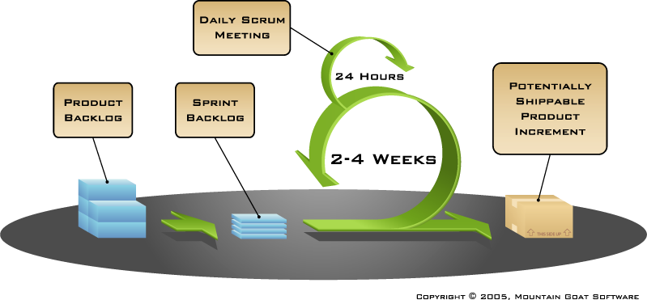

Figure 1: Scrum model

* In this project, we apply the Scum model as a development process model.

### **Project Lifecycle**

In this project, we apply the Scum model as a development process model.Scrum lifecycle is a number of consecutive steps and iterative stages that should be performed during the realization of any Scrum project. The iterative approach is the main principle of Scrum lifecycle. The work on a Scrum project is subdivided into 5 faces including Initiating segment and 4 sprints.The project develops from one sprint to another until the final product is ready. Each sprint is subdivided into several consecutive stages that it must pass from the beginning till the end.

The first step of the project is the stage of gathering necessary information about the future product. We are the person who contacts the customer to understand his vision of the future software. Gathering user stories is also one of his responsibilities. After all user stories are collected and all the customer’s wishes are considered, they are prioritized in a list that is called a product backlog. It is the main document of the project.

After the prioritization of the product backlog items, they are turned into tasks and divided into several sprints. The team makes it during the sprint planning meetings. The main goal of each meeting is to create a sprint backlog. It is a document that contains all tasks for a certain sprint. After the sprint is finished the work of the team will be estimated in accordance with the fulfillment of the sprint backlog requirements.

The next step in the Scrum lifecycle is the process of sprint execution. It includes a consequent performance of all sprint tasks and everyday evaluation of workflow. The progress of the sprint backlog requirements is evaluated during the daily Scrums – the team gatherings where all the positive and negative work issues are discussed.

After the sprint comes to its end, all members of the team participate in the sprint review and the sprint retrospectives. These gatherings help to find out what went wrong during the sprint.

The final step of every sprint is the stage of product estimation. The product is evaluated in accordance with the team’s definition of “Done” and provided to the customer to obtain his feedback. Then a new sprint starts, and the cycle repeats.

### **Roles and Responsibilities**

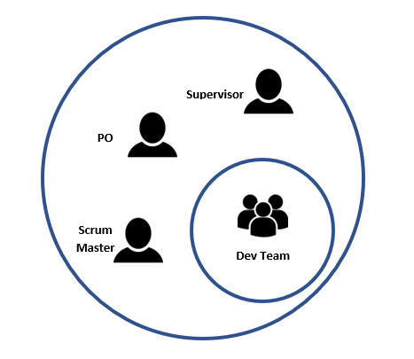

Figure 2: Project Organization Structure

|  |  |  |
| --- | --- | --- |
| Role | Full Name | Responsibility |
| **Supervisor** | Tran Binh Duong | - Give instruction for project team  - Verify deliverables  - Supervise project team’s status |
| **Scrum master - PM** | Vu Bao Yen | - Ensure Project process is followed  - Ensure a reasonable interaction between PO, Team and Supervisor  - Protect and motivate Team  - Support in organizing activities (such as meetings, infrastructure, etc.)  - Support Team to focus on work and achieve current project goals  - Working with PO to understand requirements, propose solutions, request to change stories  - Support activities such as Team building, developing skills for members, building feedback, etc.  - Detect and solve problems |
| **PO (Product Owner) - Main Customer** | Nguyen Van Dung | - Reviewing Product Backlog  - Regularly monitor the construction of user stories  - Review the functions given in each version |
| **Develop team** | Vu Bao Yen | - Understand requirements, analysis, design, product coding  - Understand and follow the project process  - Attend Kick off, Sprint Planning, Sprint Review, Daily Scrum Meeting  - Get the job, estimate and be responsible for your work for the quality and deadline  - Design test and execution test  - Bug fixes and product improvement contributions |
| Pham Trong Kim |
| Nguyen Tung Lam |
| Nguyen Thi Kim Loan |

## **TOOLS AND INFRASTRUCTURES**

### **Hardware**

* Personal computer for coding and testing with minimum configuration of 4GB RAM, Intel core 2 Duo.
* Smartphones run on web browsers.
* Internet network connection.

### **Software**

|  |  |  |
| --- | --- | --- |
| Category | Software Name | Version |
| **Operating System** | Microsoft Windows 10 | Professional |
| **Office Tools** | Microsoft Word | 2010 |
| Microsoft Excel | 2003, 2010 |
| Microsoft Powerpoint | 2010 |
| **Management Tool** | Trello |  |
| Google Drive |  |
| Facebook |  |
| **Design Tool** | https://app.lucidchart.com |  |
| **Development Tool** | IntelliJ IDEA | 2020.1.2 |
| **Database Tool** | SQL Server | 2017 |
| **Source Code**  **Management Tool** | Source Tree | 3.3.8 |
| Github.com |  |

## **SCHEDULES**

### **Detail Schedules**

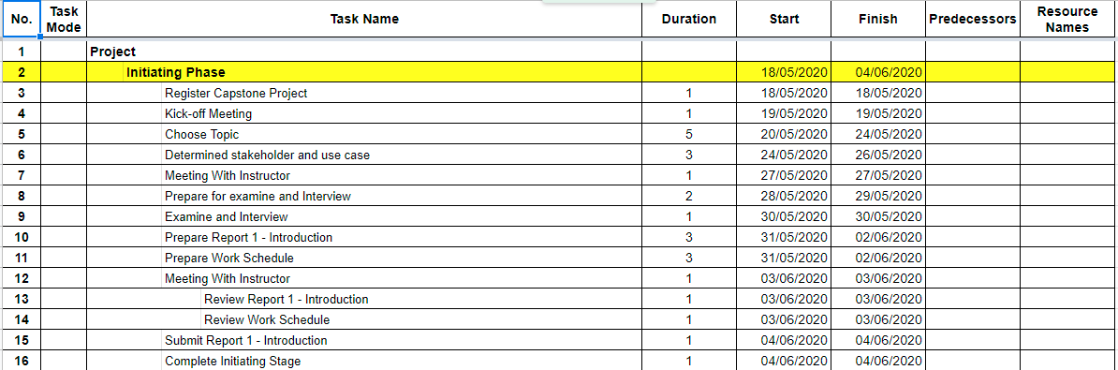

Figure 3: Schedule for Initiating Phase

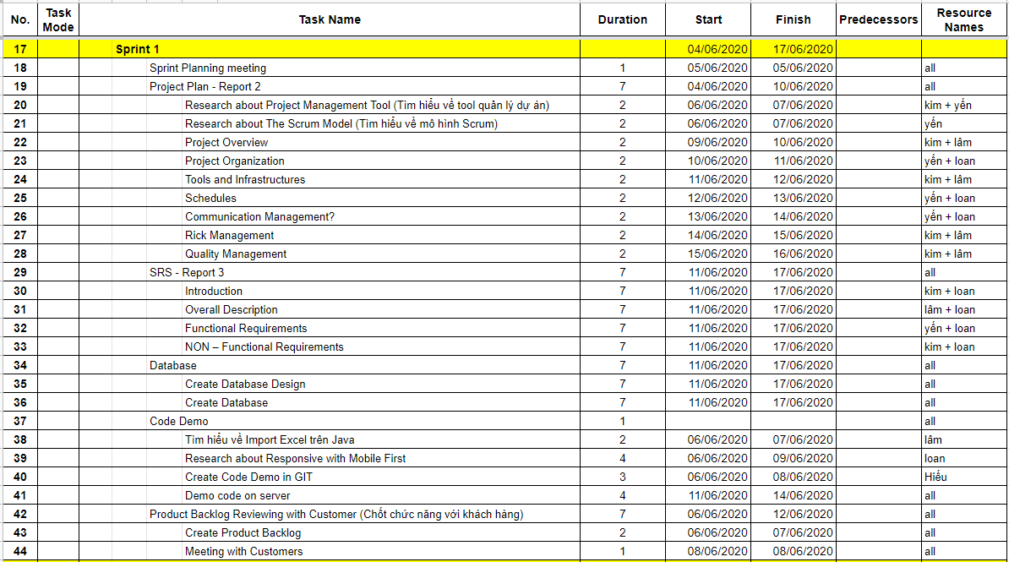

Figure 4: Schedule for Sprint 1

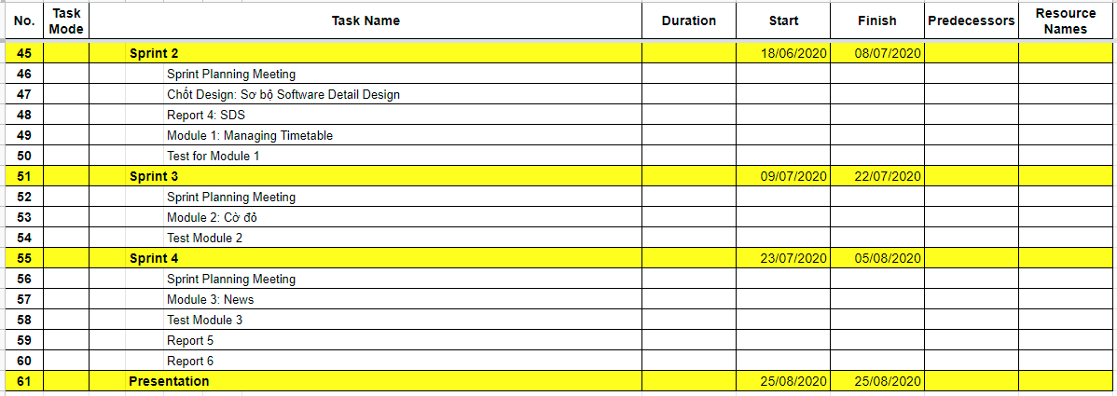

Figure 5: Schedule for Sprint 2, Sprint 3, Sprint 4 and Presentation

### **Milestones and Deliverable**

|  |  |  |  |
| --- | --- | --- | --- |
| No. | Milestones | Deliverable | Date |
| **1** | Kick-off first Meeting | Topic of project | 19/05/2020 |
| **2** | Complete Initiating Stage | Report 1 - Introduction  Project summary | 04/06/2020 |
| **3** | Sprint Planning meeting for sprint 1 | Detail plan of sprint 1 | 05/06/2020 |
| **4** | Complete Sprint 1 | Product Backlog Report 2 - project management plan Report 3 - SRS Database | 17/06/2020 |
| **5** | Sprint Planning meeting for sprint 2 | Detail plan of sprint 2 | 18/06/2020 |
| **6** | Complete Sprint 2 | Software Detail Design Report 4 - SDS  Module 1: Managing Account  Module 2: Managing Class  Module 3: Managing Timetable  Test report for Module 1  Test report for for Module 2  Test report for for Module 3 | 08/07/2020 |
| **7** | Sprint Planning meeting for sprint 3 | Detail plan of sprint 3 | 09/07/2020 |
| **8** | Complete Sprint 3 | Module 2  Test report for module 2 | 22/07/2020 |
| **9** | Sprint Planning meeting for sprint 4 | Detail plan of sprint 4 | 23/07/2020 |
| **10** | Complete Sprint 4 | Module 3  Test report for module 3  Report 5  Report 6 | 05/08/2020 |
| **11** | Submit final report of Testing | Final Report | 12/8/2020 |
| **12** | Presentation | Completed Project | 25/8/2020 |

## **COMMUNICATION MANAGEMENT**

### **Stakeholders and Contacts**

|  |  |  |  |
| --- | --- | --- | --- |
| Name | Title | Role | Contacts |
| Tran Binh Duong | Mr. | Supervisor | [duongtb@fe.edu.vn](mailto:duongtb@fe.edu.vn)  (84) 936-168-165 |
| Vuong Thanh Trung | Mr. | Customer | [trungvt130584@gmail.com](mailto:trungvt130584@gmail.com)  (84) 916-819-984 |
| Nguyen Van Dung | Mr. | Customer | (84) 911-228-595 |
| Vu Bao Yen | Mrs. | Leader | [yenvbse05610@fpt.edu.vn](mailto:yenvbse05610@fpt.edu.vn)  (84) 354-306-555 |
| Pham Trong Kim | Mr. | Member | [kimptse05423@fpt.edu.vn](mailto:kimptse05423@fpt.edu.vn)  (84) 967-191-052 |
| Nguyen Tung Lam | Mr. | Member | [lamntse05790@fpt.edu.vn](mailto:lamntse05790@fpt.edu.vn)  (84) 347-059-998 |
| Nguyen Thi Kim Loan | Mrs. | Member | [loanntkse05636@fpt.edu.vn](mailto:loanntkse05636@fpt.edu.vn)  (84) 941-687-957 |

### **Communication Management Approach**

Scrum master communicates frequently to ensure the progress of each member’s work every day in daily scrum meetings. Scum master report honestly to the Supervisor once a week so that the Supervisor can track the team’s work and give support/advice as needed.

All requests for change or proposal of new ideals must be discussed with the member, PO, and scrum master. If the project team agrees to change, Scrum master must then discuss it with the supervisor. Once the change is approved, the scrum master will update the plan.

### **Communication Requirements**

The Scrum master will communicate with the Supervisor in order to determine his preferred frequency and time of communication.

As all project team members still take part in classes while doing projects, Scrum master should communicate to understand their schedule, and therefore specify appropriate communication plans for the team.

### **Communication Method and Technologies**

* The project team will have a sprint planning meeting to define the planning that the project will do for the sprint at the beginning of the sprint.
* We have a daily meeting that lasting 15 minutes to answer some questions like What did yesterday do? What will you do today? Are there any problems?
* Create a Facebook private group for team members to discuss and share informal information and activity. This would be a place for members to communicate freely, and therefore would help in strengthen relationship between members.
* Use Google docs to share documents.
* Public weekly reports of team members in Google docs to keep them writing reports. This will help project managers in tracking work of team members, and also help team members understand the progress of others.
* Update Work schedule before weekly meeting with Supervisor.
* Manage the plan and task above Trello tool.

## **RISK MANAGEMENT**

### **Risk Management Approach**

The approach to managing risks for this project is the process by which the project team identifies and ranks the various risks. The most likely and high impact risks will be added to the risk register and will be delivered to all team members, to ensure that every member perceives these potential risks. The project manager must pay attention to all items in the risk register during the project and take appropriate action when risk is triggered. Upon the completion of the project, the project manager will analyze each risk as well as the management process. Based on this analysis, the project manager will identify any improvements that can be made to the risk management process and capture these improvements as a part of the lessons learned.

The approach to managing risks for this project is the process by which the project team identifies in every sprint meeting. Scrum master and team members will analyze each risk as well as find the solution after the sprint meeting end up. The scrum master has responsibilities to manage all risks that be defined. The team members will identify any improvements that can be made to the risk management process and capture these improvements as a part of the lessons learned in the sprint retrospection meeting after each sprint.

### **Risk Identification**

Risk identification will be conducted in the sprint meeting. The risks will be written down by a team member when all team members answer the question that is "Are there any problems?". All team members don't need to get detail on how to resolve the risk in the sprint meeting.

Otherwise, the project team can define the project risk in each sprint. The risk will appear when the project is running.

Besides, the project team will review other capstone projects in order to determine the most common risks and the strategies used to mitigate those risks.

### **Risk Qualification and Prioritization**

In order to determine the severity of the risks identified by the project team, a probability and impact factor will be assigned to each risk. Scrum master then will prioritize risks based on their probability and impact. Finally, the scrum master will create a probability – impact matrix.

### **Risk Monitoring**

Risk monitoring will be a continuous process throughout the project. The avoidance plan should be taken care of from the start of the project. In case a risk is about to happen, the Scrum master and the team members will apply a contingency plan to prevent risk. If the risk already happens, Scrum master and the team members will apply to the fall back plan to minimize the impact.

### **Risk Register**

#### **Risk description of all project**

|  |  |  |  |  |  |  |  |  |
| --- | --- | --- | --- | --- | --- | --- | --- | --- |
| **No.** | **Risk Name** | **Description** | **Category** | **Route cause** | **Probability** | **Impact** | **Risk response** | |
| **Risk Contingency** | **Risk Mitigation** |
| **R1** | Lack of skills and ability for a specified work | Team members may be unable to complete work because they have trouble in how to do. Therefore, project may be over deadline | Human | Team members have not studied or not enough experienced work.. | High | High | - Do well at the training together.  - Find materials and self-study.   - The scrum master should understand the ability of each team member and assign the right work for the right person. | - Assign more team members to support or to do the task.  - Ask for the support of external others. |
| **R2** | Team member may conflict | Team member may disagree with each others and refuse to work. Therefore, project may not enough member to complete the work | Human | Unclear requirement specification. Team members do not unify on solutions when problems occur. | Medium | High | - Clear requirement.   - Pay attention to team building activities.  - Organize discussion periodic meetings. | - Negotiate to deal with conflict in a meeting.  - Report to Supervisor |
| **R3** | Requirement may change | The scope may change, unplanned requirements may get added.Therefore, project can be over deadline and raise cost. | Requirement | Request from Supervisor or customer for new function, or to change requirement | Medium | High | - Specify software requirement between Supervisor and project team before start of development.  - Give special consideration in requirements. | - Discuss with Supervisor to decide which requirement should be implemented.  - Change requirement. Develop for new required functions. |
| **R4** | Team members may distraction | Team members may not pay enough time for the project. Therefore, project may be over deadline. | Human | Team members are busy with studying while doing project | Low | High | - Understand team members' schedule and assign suitable tasks and set appropriate deadlines.  - Require team members to set high priority for the project. | - Arrange team work frequently.  - Sketch deadline for the assigned tasks.  - Assign tasks to other members. |
| **R5** | Schedule may flaw | - Time for one task can be too long or too short.  - Trouble may occurs during process that makes task longer than expected | Estimates | - The project is planned assuming that all will take the most optimistic path possible.  - Poor plan analysis.  - Poor team member assessment. | High | High | Use the Trello tool to add deadlines for important tasks and remind team members to always follow deadlines. | - A member who has free time involve in and support to finish the task.  - If there is some task that has more time than usual, member who take responsibilities should help each other.  - Create new time schedule. |
| **R6** | Lack of Supervisor support | Supervisor may have not enough time to support project team. Therefore, the work may get more mistakes. | Human | Communicate with the Supervisor inefficiently. The supervisor is a busy personal business and support many teams at the same time | Low | High | Define a meeting schedule with the Supervisor. | Ask for support from other sources. |
| **R7** | Lack the number of unit testing | Team members are can unable to complete the implementation of unit testing. Therefore, when customers use the system, the system may have many bugs. | Estimate, Human | Lack of implementation time. Lack of close supervision | Medium | High | - Assigning the number of unit tests exactly for each member.  - Scrum master checks the testing progress. | Create and implement more unit test. |
| **R8** | The project team may lost project documents | Members can’t find project documents. Therefore, it spends lots of time writing again. | Human | Lack of managing documents. | Medium | Medium | - Save documents in multiple sources such as PC, Driver,...  - The scrum master manages documents closely. | Create new documents. |
| **R9** | Source code may be conflicted | Two or members in team can do same one part. Therefore, system may not run. | Human | - Assign the work for team members inefficient.  - Member don't understand their task. | High | High | Pull source code before commit the source code. | Use backup version, discuss with other members and continue to work. |
| **R10** | The system may not run in updated web browser | Some element don't perform well in the web browser. Therefore, system may not run. | Technology | Web don't support for system | Low | Medium | Give a list browser for customers that can run application fluently. | Consider and update the website to satisfy the new browser version. |
| **R11** | The project team may communicate with customer hardly | There is some misunderstanding between the developer team and customers. Therefore, the project team may not solve the problem of customers. | Human | Long-distance between the developer team and customer. | Medium | High | - Communicate frequently in online media.  - Reporting on a specific date with the customer. | Come and discuss directly with customers. |
| **R12** | The project team may lost member | The team may not be enough member to develop. Therefore, project may be over deadline. | Human | - When team members got sick or had accident.  - Be isolated from corona virus infection. | Low | High | - Leader remind members to take care their health  - Members protect themselves carefully. | - Assign the task of missing members to others.  - Ask support from the external resource. |
| **R13** | The team may work online | All team members quarantine themselves at home. Therefore, team members may not lose connection with others and take more time to finish tasks. | Disease | Outbreak of coronavirus. | Low | High | None | Make new planning to development project online. |
| **R14** | Product owner may be changed | The customer will be disabled to authorize the managing system. Therefore, it spends more time to transfer the system. | Human | Customers are busy or to transfer new work. | Low | Medium | None | Tranfer the project for new customers who will manage this system in the future. |

#### **Risk description of Sprint 1**

|  |  |  |  |  |  |  |  |  |
| --- | --- | --- | --- | --- | --- | --- | --- | --- |
| **No.** | **Risk Name** | **Description** | **Category** | **Route cause** | **Probability** | **Impact** | **Risk response** | |
| **Risk Contingency** | **Risk Mitigation** |
| **R15** | Team members may misunderstand the scrum process. | Team members may have trouble that they should do exactly in the project like what is the daily meeting should discuss, what is the scrum master. Therefore, the work may be not finished. | Human | Team members don't research about the scrum process. | Medium | High | Leader send the scrum process tutorial for team members. | Scrum master retrain team members about the scrum process. |
| **R16** | The report may be over deadline | Any report doesn't summit for the supervisor on-time. Therefor, it may affect to other works. | Human | Team members don't focus on their task. | High | High | Leader assigns the specific work for each member. | Team members use more effort to finish their task. |
| **R17** | The designed database may be failure | The created database is not working well in the project system and it has not a good architecture. Therefore, team members may spend more time to design the database again and implement code late. | Human | Team members have not to experience designing a good database. | High | High | - Team members researchers more about how to design a database.  - Team members discuss and review the project database. | Ask the support from the supervisor or the database expert. |
| **R18** | Demo code on server task may be not done | The demo code is not shown on-time. Therefore, customer may be not satisfied. | Human | - Team members don't focus on their task.  - The task is not estimated exactly. | High | High | Scrum master check the task deadline of each members. | - Team members use more effort to finish their task.  - Scrum master set a new deadline for their task. |

#### **Risk description of Sprint 2**

|  |  |  |  |  |  |  |  |  |
| --- | --- | --- | --- | --- | --- | --- | --- | --- |
| **No.** | **Risk Name** | **Description** | **Category** | **Route cause** | **Probability** | **Impact** | **Risk response** | |
| **Risk Contingency** | **Risk Mitigation** |
| **R19** | Logic Bug | Team members may misunderstand flowchart of function. Therefore, team members may spend more time to fix bug. | Human | - Team members don't focus on their task.  - Document is not enough detailed. | High | High | - Scrum master check the task deadline of each members.  - Scrum master check source code. | - Team members use more effort to finish their task.  - Scrum master set a new deadline for their task.  - Team member updates document. |
| **R20** | Source code may conflict | Team members push wrong branch in github. Therefore, team members may spend more time to restore code. | Human | - Team members don't focus on their task.  - Team members misunderstand commit code process. | High | High | - Scrum master guides using github process.  - Scrum master check request merger of team members. | Team members ask scrum master to solve problems. |
| **R21** | Risk about technique | Team members may not have enough knowledge about new technology to develop. Therefore, team members may spend time to research new technology. | Human | The first time team members use spring frame work | High | High | Team members spend more time to research. | Team members ask master about spring boot to support. |
| **R22** | The project team may contact with customer hardly | Team members may contact with customer hardly that about exchange more about project requirements. Therefore, the working process may be lated. | Human | - Long-distance between the developer team and customer.  - Customers are teacher so they are busy on end of year. | High | High | Team members are more proactive to contact and get an appointment with the customer for convenient working time. | Team members proceed develop function follow explicit request in advance. |
| **R23** | The project team may create sketchy design for modules | The team members may create sketchy designs for modules. Therefore, the system may happen a lot of bug and spend more time designing again. | Human | Team members have not enough time and contact hardly with customer. | High | High | Team members arrange the working schedules to fit with customer's working time. | Team members use more effort to design again. |

#### **Risk description of Sprint 3**

|  |  |  |  |  |  |  |  |  |
| --- | --- | --- | --- | --- | --- | --- | --- | --- |
| **No.** | **Risk Name** | **Description** | **Category** | **Route cause** | **Probability** | **Impact** | **Risk response** | |
| **Risk Contingency** | **Risk Mitigation** |
| **R24** | Logic Bug | Team members may misunderstand flowchart of function. Therefore, team members may spend more time to fix bug. | Human | - Team members don't focus on their task.  - Document is not enough detailed. | Medium | High | - Scrum master check the task deadline of each members.  - Scrum master check source code. | - Team members use more effort to finish their task.  - Scrum master set a new deadline for their task.  - Team member updates document. |
| **R25** | May execute wrong testing process | Team members may make mistake about how to execute test process. Therefore, it may spend more time to test again. | Human | Team members don't have experience of testing. | High | High | Team members researchers more about how to testing. | Ask support from the external resource. |
| **R26** | Source code may conflict | Team members push wrong branch in github. Therefore, team member may spend more time restoring code. | Human | - Team members don't focus on their task.  - Team members misunderstand commit code process. | High | High | - Scrum master guides using github process.  - Scrum master check request merger of team members. | Team members ask scrum master to solve problems. |
| **R27** | The working time may be limited | Team members may not have enough time to finish their tasks | Human | Team members have to spend time for assignments in class | High | High | Scrum master assign tasks effectively with the team members time. | Team members use more effort to finish their task. |
| **R28** | The solution for assigned redstar may have the problem | May not find the best solution to solve the assigned Redstar automatically. Therefore, the system may not do mission well. | Human | The assigned problem is very complicated and spent more effort to solve | Medium | High | Team members researchers more about similar problems and how to solve them. | Ask support from the supervisor. |

#### **Risk description of Sprint 4**

|  |  |  |  |  |  |  |  |  |
| --- | --- | --- | --- | --- | --- | --- | --- | --- |
| **No.** | **Risk Name** | **Description** | **Category** | **Route cause** | **Probability** | **Impact** | **Risk response** | |
| **Risk Contingency** | **Risk Mitigation** |
| **R29** | Logic Bug | Team members may misunderstand flowchart of function. Therefore, team members may spend more time to fix bug. | Human | - Team members don't focus on their task.  - Document is not enough detailed. | Low | High | - Scrum master check the task deadline of each members.  - Scrum master check source code. | - Team members use more effort to finish their task.  - Scrum master set a new deadline for their task.  - Team member updates document. |
| **R30** | May execute wrong testing process | Team members may make mistake about how to execute test process. Therefore, it may spend more time to test again. | Human | Team members don't have experience of testing. | Low | Medium | Team members researchers more about how to testing. | Ask support from the external resource. |
| **R31** | Source code may conflict | Team members push wrong branch in github. Therefore, team member may spend more time restoring code. | Human | - Team members don't focus on their task.  - Team members misunderstand commit code process. | Medium | High | - Scrum master guides using github process.  - Scrum master check request merger of team members. | Team members ask scrum master to solve problems. |
| **R32** | Overtime dateline of deploying | Team members may have the problem with how to deploy project. Therefore, it may affect other works and make customers dissatisfied. | Human | Team members don't have experience of deploying. | High | High | Team members researchers more about how to deploying. | Ask support from the external resource. |
| **R33** | The deadline may not on-time | Team members lost a week for examination. Therefore, member's task may not finish on time. | Human | Team member has to finish their final examination for a week. | High | High | None | Team members use more effort to finish their task. |
| **R34** | The project team may contact with customer hardly | Communication with customer hardly.Therefore, the project team may not solve the problem of customers. | Human | Covid-19 is spread again. | High | High | None | Team members work on online media like google meet. |

#### **Probability – Impact matrix**

|  |  |  |  |  |
| --- | --- | --- | --- | --- |
| **Probability** | High |  |  | R1, R5, R9, R16, R17, R18, R19, R21, R22, R23, R25, R26, R27, R32, R33, R34 |
| Medium |  | R8 | R2, R3, R7, R11, R15. R24, R28, R31 |
| Low |  | R10, R14, R30 | R4, R6, R12, R13, R29 |
|  | Low | Medium | High |
|  | **Impact** | | | |

Figure 6: Probability – Impact matrix

### **Risk Implement**

|  |  |  |  |  |
| --- | --- | --- | --- | --- |
| **No.** | **Risk Contingency** | **Risk Mitigation** | **Other Risk Mitigation** | **Occurent Status** |
|  |
| **R1** | - Do well at the training together. - Find materials and self-study.  - The scrum master should understand the ability of each team member and assign the right work for the right person. | - Assign more team members to support or to do the task. - Ask for the support of external others. | None | Yes |  |
| **R2** | - Clear requirement.  - Organize discussion periodic meetings. | - Negotiate to deal with conflict in a meeting. - Report to Supervisor | None | Yes |  |
| **R3** | - Specify software requirement between Supervisor and project team before start of development. - Give special consideration in requirements. | - Discuss with Supervisor to decide which requirement should be implemented. - Change requirement. Develop for new required functions. | None | Yes |  |
| **R4** | - Understand team members' schedule and assign suitable tasks and set appropriate deadlines. - Require team members to set high priority for the project. | None | None | No |  |
| **R5** | Use the Trello tool to add deadlines for important tasks and remind team members to always follow deadlines. | - A member who has free time involve in and support to finish the task. - If there is some task that has more time than usual, member who take responsibilities should help each other. - Create new time schedule | None | No |  |
| **R6** | Define a meeting schedule with the Supervisor. | None | None | No |  |
| **R7** | - Assigning the number of unit tests exactly for each member. - Scrum master checks the testing progress. | None | None | No |  |
| **R8** | - Save documents in multiple sources such as PC, Driver,... | None | None | No |  |
| **R9** | Pull source code before commit the source code | None | None | No |  |
| **R10** | None | None | None | No |  |
| **R11** | - Communicate frequently in online media - Reporting on a specific date with the customer | None | None | No |  |
| **R12** | - Leader remind members to take care their health - Members protect themselves carefully. | None | None | No |  |
| **R13** | None | None | None | No |  |
| **R14** | None | None | None | No |  |
| **R15** | Leader send the scrum process tutorial for team members. | None | None | No |  |
| **R16** | Leader assigns the specific work for each member. | None | None | No |  |
| **R17** | - Team members researchers more about how to design a database. - Team members discuss and review the project database. | Ask the support from the supervisor or the database expert. | Team meber gives improved way database | Yes |  |
| **R18** | Scrum master check the task deadline of each members | - Team members use more effort to finish their task. - Scrum master set a new deadline for their task. | None | Yes |  |
| **R19** | - Scrum master check the task deadline of each members.  - Scrum master check source code. | - Team members use more effort to finish their task. - Scrum master set a new deadline for their task. - Team member updates document. | None | Yes |  |
| **R20** | - Scrum master guides using github process. - Scrum master check request merger of team members. | Team members ask scrum master to solve problems. | Team members cancel request merge. | Yes |  |
| **R21** | Team members spend more time to research. | None | None | No |  |
| **R22** | Team members are more proactive to contact and get an appointment with the customer for convenient working time | Team members proceed develop function follow explicit request in advance. | None | Yes |  |
| **R23** | Team members arrange the working schedules to fit with customer's working time. | None | None | No |  |
| **R24** | - Scrum master check the task deadline of each members. - Scrum master check source code. | - Team members use more effort to finish their task. - Scrum master set a new deadline for their task. - Team member updates document. | None | Yes |  |
| **R25** | Team members researchers more about how to testing. | Ask support from the external resource. | None | Yes |  |
| **R26** | - Scrum master guides using github process. - Scrum master check request merger of team members. | Team members ask scrum master to solve problems. | None | Yes |  |
| **R27** | Scrum master assign tasks effectively with the team members time. | Team members use more effort to finish their task. | None | Yes |  |
| **R28** | Team members researchers more about similar problems and how to solve them. | Ask support from the supervisor. | None | Yes |  |
| **R29** | - Scrum master check the task deadline of each members. - Scrum master check source code. | - Team members use more effort to finish their task. - Scrum master set a new deadline for their task. - Team member updates document. | None | Yes |  |
| **R30** | Team members researchers more about how to testing. | None | None | No |  |
| **R31** | - Scrum master guides using github process. - Scrum master check request merger of team members. | None | None | No |  |
| **R32** | Team members researchers more about how to deploying. | Ask support from the external resource. | None | Yes |  |
| **R33** | None | Team members use more effort to finish their task. | None | Yes |  |
| **R34** | None | Team members work on online media like google meet. | None | Yes |  |

## **QUALITY MANAGEMENT**

### **Quality Management Overview**

#### **Organization, Role and Responsibilities for quality management**

|  |  |  |
| --- | --- | --- |
| Name | Role | Responsibilities |
| Tran Binh Duong | Supervisor | - Helps define product quality expectations.  - Determines final acceptance product’s quality |
| Vu Bao Yen | Scum Master | - Create quality plan  - Facilitate resolution of quality issues, escalating as needed. |
| Team members:   * Nguyen Tung Lam * Pham Trong Kim * Nguyen Thi Kim Loan | Developer | - Create test plan  - Create test cases  - Execute text cases  - Report test result |
| HVT Gifted High School | Tester | - Execute acceptance tests. |

#### **Tools, Environment, and Interfaces**

|  |  |
| --- | --- |
| Tool | Description |
| Cause-and-effect  diagram | Used to find the root cause problem when there is a complaint about quality problems. |
| Flowchart | Used to illustrate a solution model for a problem. |

### **Quality Planning**

#### **Define Project Quality**

* **System output:**
* A Web application supports evaluating the emulation grades, managing school activities and timetables.
* **Functionality:**
* Follow the requirements of the project.
* **Performance:**
* Time delay for system processing is less than 10s.
* **Reliability:**
* The application is available 24/7.
* Server can handle a least 200 clients concurrently.
* **Maintainability:**
* Web applications are easily to be updated without any crashes. Source code is readability, complies with coding convention.
* System has to be designed to be easy to extend.
* **Security:**
* Information of admin and manager on server is secured.

#### **Measure Project Quality**

|  |  |
| --- | --- |
| Metric | Goal |
| Response of the web application | Time delay for image processing <= 10s |
| Bugs/Lines of Code | UT: 8 – 9 bugs / KLOC  ST: 2 – 4 bugs / KLOC  ( based on Fsoft norms) |
| Maximum deep of loops | <= 4 |
| Algorithm complexity | <= O(n^2) |
| Website support browser | Support Chrome version 41.0.xxx, Firefox  version 36.0 or later. |

#### **Improve Project Quality**

|  |  |
| --- | --- |
| Issue | Action |
| Difficult to track project’s progress | * Weekly report, team work 6 days/ week * Using Trello to track team members’ work |
| Maintainability | * Specify coding conventions document * Concentrate on architecture design |
| Low quality code | * Peer review, peer coding among developers |
| Reward and discipline | * Teambuilding to increase communication ability between project’s members * Have punishment rules when: * Submit terrible code (which causes to re-coding more than 10%) * Miss deadline |
| Acceptance of users | Conduct meetings face-to-face and contacts through Facebook, email, phone. |

### **Quality Control**

|  |  |  |  |
| --- | --- | --- | --- |
| Deliverables | Goal | Quality control  activity | Frequency /  Interval |
| **Interface Design** | - Good looking & easy-to-use.  - Cover all functions  specified in SRS | Designer has to:  - Ask for advice of some other designer  - Take comment from friends on completed work  - Have approve from SRS leader | Each time design a new screen |
| **Software**  **Architecture**  **Design** | Design to be easy to extend | Have review and judgment from Supervisor | On completion design |
| **Integration Test Report** | 30 – 34 test cases /KLOC  2 – 4 bugs /KLOC | PM requires testers to report on work. | Twice in a month. |
| **System Test**  **Report** | 30 – 34 test cases /  KLOC  2 – 4 bugs / KLOC | PM requires testers to report on work | Twice in a month. |